Final Project: Final Project

Brandon Trinkle

Arizona State University

Course Number: IFT 360

Professor Durgesh Sharma

10/9/24

**Football Game Strategy AI (Coach's Assistant)**

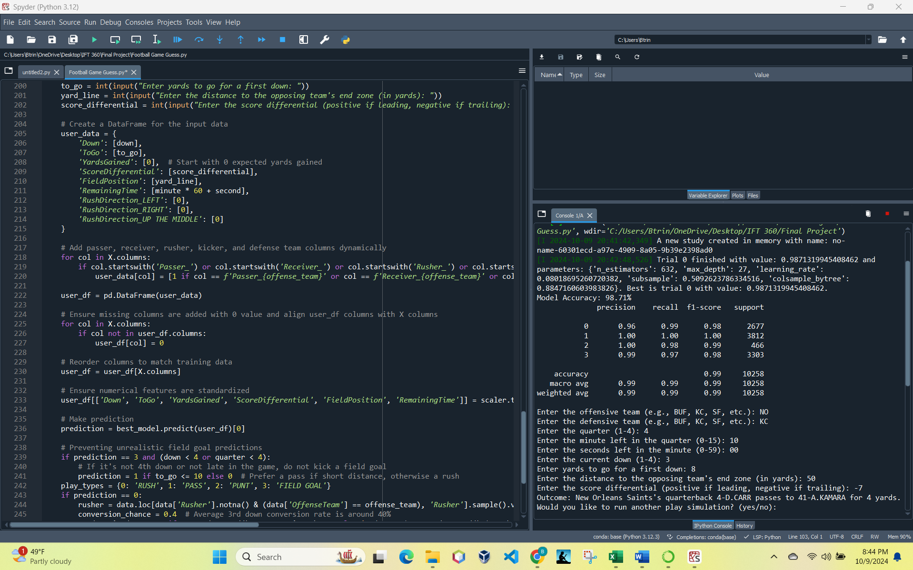

**Data set:**

pbp-2023.csv (NFL Savant, 2024)

**Zoom Recording Link:**

https://asu.zoom.us/rec/share/LO_PGhYjhhJJiN2qRd09-49XR_a03MqwIW6F7yY31cHSqCB1u-FpHJQwf0WdQCrT.WWz9sgFCXQCmEVZC?startTime=1728522849000

Passcode: YSK0vz$8

*I could not get audio to work, so I provided a summary of the model along with a description of the functions. I wanted to share how I was able to use this to successfully predict a touchdown during the Monday night game of New Orleans vs. Kansas City.*

**Summary:**

This project is a football play prediction model that is used to forecast play types such as rush, pass, punt, or field goal. The scope of this project involves applying machine learning to historical football data to predict future plays based on game conditions. The model uses XGBoost, a powerful boosting algorithm known for its efficiency and accuracy in handling complex datasets. I train this model using a dataset containing all the plays from 2023 season, and I use feature extraction techniques to derive key elements like passer, receiver, yards gained, and situational context such as score differential and field position. These features are crucial in understanding the strategic decisions that teams make. To enhance the model's predictive power, we use Optuna, which performs hyperparameter optimization. This process can be thought of as a guided search—similar to an optimization problem—where Optuna explores various parameter combinations to maximize the model's performance. This is not a traditional search like depth-first or breadth-first but rather an optimization search, balancing between exploration and exploitation to find the best settings for the model.

Once trained, the model uses a greedy-like approach to predict the play type that has the highest probability given the current game situation. By incorporating a game scenario, such as down, distance, and score, the model makes informed predictions, aiming to mirror the decision-making process of a coach. Additionally, we add logic to prevent unrealistic predictions, such as avoiding a field goal on third down unless it's a critical scenario. Which is how the model initially handeld unknown scenarios like 2nd and 40 (no data exists for that scenario).

This project showcases how AI can be applied in sports analytics, using data-driven insights to predict strategic decisions and help us better understand the dynamics of the game.

**Functions:**

extract_play_features(description):

Extracts detailed features from the Description column of each play. Identifies whether a pass was completed, who the passer and receiver were, the direction of a rush, yards gained, if a turnover (fumble or interception) occurred, and identifies the kicker. Uses regular expressions to parse the play description and return various features.

objective(trial):

A function used by Optuna for hyperparameter optimization. Defines a parameter space (n_estimators, max_depth, learning_rate, subsample, and colsample_bytree) and trains an XGBoost model. Evaluates the model’s accuracy on a validation set and returns the score to guide further parameter tuning.

predict_play_scenario():

Allows user interaction to simulate a game scenario. Takes input from the user, including offensive and defensive teams, quarter, down, yards to go, etc. Constructs a feature set based on user inputs, transforms the data to align with the training features, and uses the trained model to predict the play type. Contains logic to prevent unrealistic outcomes, such as avoiding a field goal on non-critical downs. Provides a detailed description of the predicted play, incorporating player names and yardage outcomes.

**Example of Dataset:**

**Code:**

# -*- coding: utf-8 -*-

"""

Author: Brandon Trinkle

Class: IFT 360

Professor Durgesh Sharma

"""

import pandas as pd

import re

import numpy as np

from sklearn.preprocessing import StandardScaler

from sklearn.model_selection import train_test_split

from xgboost import XGBClassifier

from sklearn.metrics import accuracy_score, classification_report

import optuna

# Load the dataset

file_path = 'C://Users//Btrin//OneDrive//Desktop//IFT 360//Final Project//pbp-2023.csv'

data = pd.read_csv(file_path)

# Define team abbreviations map

team_abbreviations = {

'ARI': 'Arizona Cardinals',

'ATL': 'Atlanta Falcons',

'BAL': 'Baltimore Ravens',

'BUF': 'Buffalo Bills',

'CAR': 'Carolina Panthers',

'CHI': 'Chicago Bears',

'CIN': 'Cincinnati Bengals',

'CLE': 'Cleveland Browns',

'DAL': 'Dallas Cowboys',

'DEN': 'Denver Broncos',

'DET': 'Detroit Lions',

'GB': 'Green Bay Packers',

'HOU': 'Houston Texans',

'IND': 'Indianapolis Colts',

'JAX': 'Jacksonville Jaguars',

'KC': 'Kansas City Chiefs',

'LV': 'Las Vegas Raiders',

'LAC': 'Los Angeles Chargers',

'LAR': 'Los Angeles Rams',

'MIA': 'Miami Dolphins',

'MIN': 'Minnesota Vikings',

'NE': 'New England Patriots',

'NO': 'New Orleans Saints',

'NYG': 'New York Giants',

'NYJ': 'New York Jets',

'PHI': 'Philadelphia Eagles',

'PIT': 'Pittsburgh Steelers',

'SF': 'San Francisco 49ers',

'SEA': 'Seattle Seahawks',

'TB': 'Tampa Bay Buccaneers',

'TEN': 'Tennessee Titans',

'WAS': 'Washington Commanders'

}

# Extract new features from the 'Description' column

def extract_play_features(description):

is_pass_completed = 0

rush_direction = None

yards_gained = 0

passer = None

receiver = None

rusher = None

is_intercepted = 0

is_fumble = 0

kicker = None

# Check if the pass was completed and extract passer and receiver

pass_match = re.search(r"(\d{1,2}-[A-Z]\.[A-Za-z]+) PASS .*? TO (\d{1,2}-[A-Z]\.[A-Za-z]+)", description)

if pass_match:

passer = pass_match.group(1)

receiver = pass_match.group(2)

if "COMPLETE" in description:

is_pass_completed = 1

if "INTERCEPTED" in description:

is_intercepted = 1

# Extract rusher if it's a rush play

rush_match = re.search(r"(\d{1,2}-[A-Z]\.[A-Za-z]+) .*?(UP THE MIDDLE|LEFT|RIGHT)", description)

if rush_match:

rusher = rush_match.group(1)

rush_direction = rush_match.group(2)

# Extract yards gained

yards_match = re.search(r"(\d+)\s+YARD", description)

if yards_match:

yards_gained = int(yards_match.group(1))

# Extract kicker if it's a field goal

kicker_match = re.search(r"(\d{1,2}-[A-Z]\.[A-Za-z]+) .*?FIELD GOAL", description)

if kicker_match:

kicker = kicker_match.group(1)

# Extract fumble information

if "FUMBLE" in description:

is_fumble = 1

return is_pass_completed, rush_direction, yards_gained, passer, receiver, rusher, is_intercepted, is_fumble, kicker

# Apply the function

data[['IsPassCompleted', 'RushDirection', 'YardsGained', 'Passer', 'Receiver', 'Rusher', 'IsIntercepted', 'IsFumble', 'Kicker']] = data['Description'].apply(lambda x: pd.Series(extract_play_features(str(x))))

# Score differential feature

if 'ScoreDifferential' not in data.columns:

data['ScoreDifferential'] = data.get('OffenseScore', 0) - data.get('DefenseScore', 0) # Placeholder feature, calculate difference if scores available # Placeholder feature

# Field position feature representing the distance to the end zone

if 'FieldPosition' not in data.columns:

if 'YardLine' in data.columns:

data['FieldPosition'] = data['YardLine']

else:

data['FieldPosition'] = 50 # Default value for field position if not available

# Remaining time as a feature calculated from minute and second columns

if 'RemainingTime' not in data.columns:

if 'Minute' in data.columns and 'Second' in data.columns:

data['RemainingTime'] = data['Minute'] * 60 + data['Second'] # Calculate remaining time in seconds

else:

data['RemainingTime'] = 0 # Default value for remaining time if not available # Calculate remaining time in seconds

# Prepare features and target variable

rush_direction_dummies = pd.get_dummies(data['RushDirection'], prefix='RushDirection')

passer_dummies = pd.get_dummies(data['Passer'], prefix='Passer')

receiver_dummies = pd.get_dummies(data['Receiver'], prefix='Receiver')

rusher_dummies = pd.get_dummies(data['Rusher'], prefix='Rusher')

kicker_dummies = pd.get_dummies(data['Kicker'], prefix='Kicker')

# Add score differential

data = pd.concat([data, rush_direction_dummies, passer_dummies, receiver_dummies, rusher_dummies, kicker_dummies], axis=1)

# Drop unnecessary columns for model training

X = data.drop(columns=['Description', 'RushDirection', 'PlayType', 'GameId', 'GameDate', 'Passer', 'Receiver', 'Rusher', 'Kicker', 'Minute', 'Second'])

y = data['PlayType'].apply(lambda x: 0 if x == 'RUSH' else (1 if x == 'PASS' else (2 if x == 'PUNT' else 3)))

# Convert boolean columns to integers and handle non-numeric values

X = X.apply(pd.to_numeric, errors='coerce').fillna(0)

# Ensure target variable has no NaN values

y = y.fillna(0).astype(int)

# Split the data into training and testing sets

X_train, X_test, y_train, y_test = train_test_split(X, y, test_size=0.2, random_state=42)

# Standardize the numerical features

scaler = StandardScaler()

X_train[['Down', 'ToGo', 'YardsGained', 'ScoreDifferential', 'FieldPosition', 'RemainingTime']] = scaler.fit_transform(X_train[['Down', 'ToGo', 'YardsGained', 'ScoreDifferential', 'FieldPosition', 'RemainingTime']])

X_test[['Down', 'ToGo', 'YardsGained', 'ScoreDifferential', 'FieldPosition', 'RemainingTime']] = scaler.transform(X_test[['Down', 'ToGo', 'YardsGained', 'ScoreDifferential', 'FieldPosition', 'RemainingTime']])

# Hyperparameter Tuning for XGBoost Model

def objective(trial):

param = {

'objective': 'multi:softmax',

'num_class': 5,

'n_estimators': trial.suggest_int('n_estimators', 100, 1500),

'max_depth': trial.suggest_int('max_depth', 5, 30),

'learning_rate': trial.suggest_float('learning_rate', 0.01, 0.1, log=True),

'subsample': trial.suggest_float('subsample', 0.5, 1.0),

'colsample_bytree': trial.suggest_float('colsample_bytree', 0.5, 1.0)

}

model = XGBClassifier(**param)

model.fit(X_train, y_train)

y_pred = model.predict(X_test)

return accuracy_score(y_test, y_pred)

study = optuna.create_study(direction='maximize')

study.optimize(objective, n_trials=1)

best_params = study.best_params

best_model = XGBClassifier(**best_params)

best_model.fit(X_train, y_train)

# Test the model's accuracy with the best parameters

y_pred = best_model.predict(X_test)

accuracy = accuracy_score(y_test, y_pred)

print(f"Model Accuracy: {accuracy * 100:.2f}%")

# Display classification report

classification_rep = classification_report(y_test, y_pred)

print(classification_rep)

# Function to make predictions based on user input

def predict_play_scenario():

while True:

offense_team = input("Enter the offensive team (e.g., BUF, KC, SF, etc.): ").upper()

if offense_team in team_abbreviations:

break

else:

print("Invalid team abbreviation. Please try again.")

while True:

defense_team = input("Enter the defensive team (e.g., BUF, KC, SF, etc.): ").upper()

if defense_team in team_abbreviations:

break

else:

print("Invalid team abbreviation. Please try again.")

quarter = int(input("Enter the quarter (1-4): "))

minute = int(input("Enter the minute left in the quarter (0-15): "))

second = int(input("Enter the seconds left in the minute (0-59): "))

down = int(input("Enter the current down (1-4): "))

to_go = int(input("Enter yards to go for a first down: "))

yard_line = int(input("Enter the distance to the opposing team's end zone (in yards): "))

score_differential = int(input("Enter the score differential (positive if leading, negative if trailing): "))

# Create a DataFrame for the input data

user_data = {

'Down': [down],

'ToGo': [to_go],

'YardsGained': [0], # Start with 0 expected yards gained

'ScoreDifferential': [score_differential],

'FieldPosition': [yard_line],

'RemainingTime': [minute * 60 + second],

'RushDirection_LEFT': [0],

'RushDirection_RIGHT': [0],

'RushDirection_UP THE MIDDLE': [0]

}

# Add passer, receiver, rusher, kicker, and defense team columns dynamically

for col in X.columns:

if col.startswith('Passer_') or col.startswith('Receiver_') or col.startswith('Rusher_') or col.startswith('Kicker_') or col.startswith('DefenseTeam_'):

user_data[col] = [1 if col == f'Passer_{offense_team}' or col == f'Receiver_{offense_team}' or col == f'Rusher_{offense_team}' or col == f'Kicker_{offense_team}' or col == f'DefenseTeam_{defense_team}' else 0]

user_df = pd.DataFrame(user_data)

for col in X.columns:

if col not in user_df.columns:

user_df[col] = 0

# Reorder columns to match training data

user_df = user_df[X.columns]

# Ensure numerical features are standardized

user_df[['Down', 'ToGo', 'YardsGained', 'ScoreDifferential', 'FieldPosition', 'RemainingTime']] = scaler.transform(user_df[['Down', 'ToGo', 'YardsGained', 'ScoreDifferential', 'FieldPosition', 'RemainingTime']])

# Make prediction

prediction = best_model.predict(user_df)[0]

# Preventing unrealistic predictions

if prediction == 3 and (down < 4 or quarter < 4):

# If it's not 4th down or not late in the game, do not kick a field goal

prediction = 1 if to_go <= 10 else 0 # Prefer a pass if short distance, otherwise a rush

play_types = {0: 'RUSH', 1: 'PASS', 2: 'PUNT', 3: 'FIELD GOAL'}

if prediction == 0:

rusher = data.loc[data['Rusher'].notna() & (data['OffenseTeam'] == offense_team), 'Rusher'].sample().values[0] if offense_team in data['OffenseTeam'].values else 'Unknown Rusher'

conversion_chance = 0.4 # Average 3rd down conversion rate is around 40%

yards_gained = to_go if np.random.rand() < conversion_chance else int(to_go * np.random.rand() * 0.5) # 40% chance to get the first down, otherwise gain between 0-50% of to_go

outcome = f"{team_abbreviations[offense_team]}'s running back {rusher} runs for {yards_gained} yards."

elif prediction == 1:

passer = data.loc[data['Passer'].notna() & (data['OffenseTeam'] == offense_team), 'Passer'].sample().values[0] if offense_team in data['OffenseTeam'].values else 'Unknown Quarterback'

receiver = data.loc[data['Receiver'].notna() & (data['OffenseTeam'] == offense_team), 'Receiver'].sample().values[0] if offense_team in data['OffenseTeam'].values else 'Unknown Receiver'

yards_gained = int(max(1, to_go * 0.5 + (to_go * 0.5 * np.random.rand()))) # Randomly predict between 50% to 100% of yards to go

outcome = f"{team_abbreviations[offense_team]}'s quarterback {passer} passes to {receiver} for {yards_gained} yards."

else:

outcome = f"Predicted play type: {play_types[prediction]}"

print(f"Outcome: {outcome}")

while True:

predict_play_scenario()

repeat = input("Would you like to run another play simulation? (yes/no): ").strip().lower()

if repeat != 'yes':

break

# References

NFL Savant. (2024, October 6). *Yearly Team Stats*. Retrieved from NFLsavant.com: https://nflsavant.com/about.php